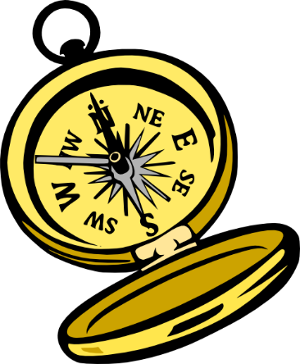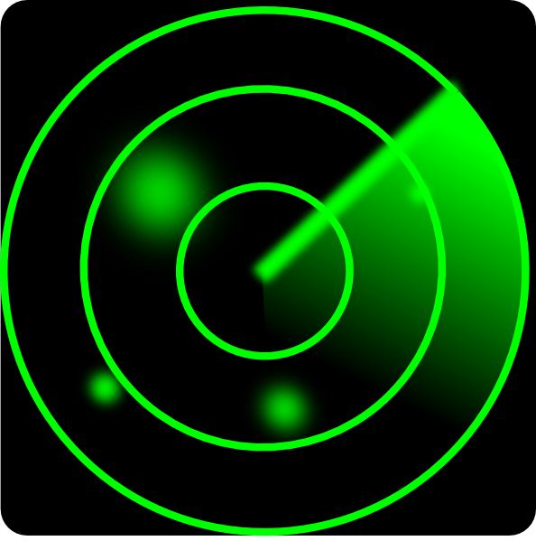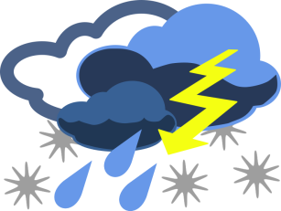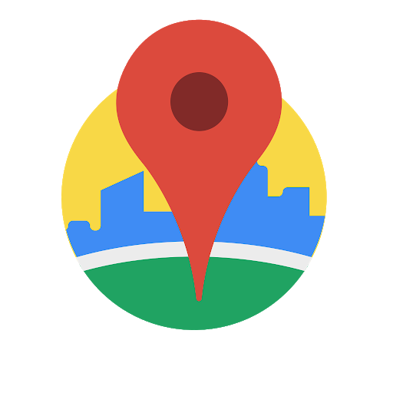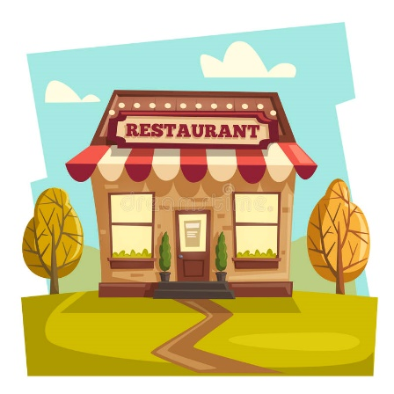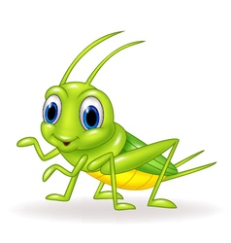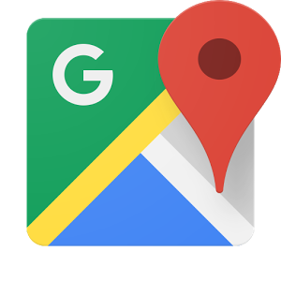

**Direction List**

**The One App For Your Night Out**

**Restaurant Radar**

**DIRECTIONS**

**MODE OF TRAVEL?**

**WHICH ONE?**

**OPEN OR ALL?**

**RESTAURANTS?**

**WEATHER?**

**PLEASE ENTER**

**LOCATION?**

**YES OR NO?**

r

r

**DarkSky Weather**

**Google Places API**

**Restaurant List**

**Grasshopper API**

**Google Maps API**